Scenario 1

When both project and repository name are given same

when executing the workflow please make sure you are on the correct branch

If you want to migrate entire TFVC repository type project to GitHub Please make sure to select the project name in ‘Select the TFS Project” Drop down and select the same Name in “Select the Repository” Drop down as well. So that the script will consider migrating the entire TFVC project into one Github repository and it will make all the content which are in TFVC as a sub folder in newly created GitHub repository.

TFVC project in TFS

After migration

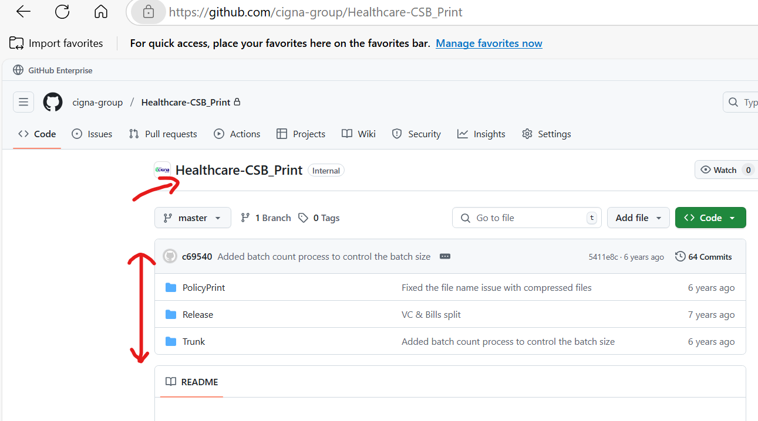

Note: In this type of scenarios the TFS Project name and the GitHub repository name will be same.

Scenario 2:

When Project name and Repository name are different

Usecase: When you need a folder or branch in a TFVC project as separate repository in GitHub you need to select like below shown screenshot and run the workflow.

After the successful workflow execution the repository will be created like below screenshot

Note: Name of the new repository will be with TFS Project name followed by repository name that is selected in the run workflow dropdown